

Setting up a Server

on Discord
This Photo by Unknown Author is licensed under CC BY-SA-NC

By Chelsea McDaniel

Table of Contents
What is Discord? ……………………………………………………………………………………………………………………… 3
Ways to use Discord ………………………………………………………………………………………………………………… 4
What is a Discord Server? ………………………………………………………………………………………………………… 5
How to set up a server …………………………………………………………………………………………………………… 6
What are channels? ………………………………………………………………………………………………………………… 8
How to set up a channel……………………….………………………………………………………………………………… 10
Adding members …………………………………………………………………………………………………………………… 11
Giving members roles ……………………………………………………………………………………………………………. 13
Chatting via Text …………………………………………………………………………………………………………………….. 17
Video chat ……………………………………………………………………………………………………………………………… 22
Streaming and screen sharing ……………………………………………………………………………………………….. 23
Discord Support ……………………………………………………………………………………………………………………. 25
Credits …………………………………………………………………………………………………………………………………... 26

What is Discord?
This Photo by Unknown Author is licensed under CC BY-SA-NC
Discord is a unique platform offering multiple methods of communicating with others, while being free to use with pay-to-play options for those who would like to enrich their experience with enhanced abilities such as advanced profile customization, server admin perks, and more.

Discord boasts of an organized layout that gives users
the ability to participate in multiple different chat rooms (or, servers) with different levels of organization.

Ways to use Discord
The primary use of Discord is to allow different people to communicate with each other.
Friends
Users can download Discord to interact with friends through text and video. Discord boasts many different capabilities to suit the needs of many users, such as text, voice, video, streaming, and more.
Work
Businesses or workplaces can utilize Discord as a means to speak to others within an organization, or to customers and patrons. A huge bonus to using Discord as opposed to a chat bot or other platform is that it is more personal and may impart a sense of connection between the patron and the organization.
School
Schools of all different grades can use Discord as an avenue for students to talk to teachers, faculty, and other students. Because of the fact that Discord gives server hosts admin abilities such as banning certain language, assigning permissions, and monitoring capabilities, this makes Discord an excellent platform to allow communication between classes.



What is a Discord Server?
Discord’s method of organization is based off of servers, which are communities contained in an invite-only space similar to a chat room. The host(s) of the server can invite users to join the server through a special link that they can click on to automatically join the server.
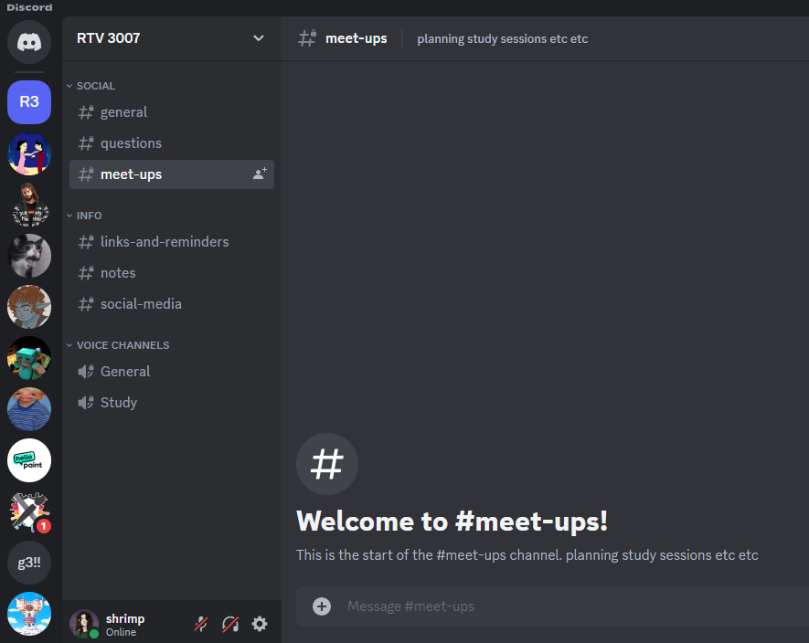

Servers have multiple organizational capabilities such as channels and roles, which will be discussed in upcoming chapters. They can be created for different communities such as study groups, art instructions, gaming streamers, and more.

How to Set Up a Server

- To create a server, scroll all the way down in the left-most panel until a plus sign in a circle is visible. When the mouse is hovered over this icon, it will say “Add a Server”

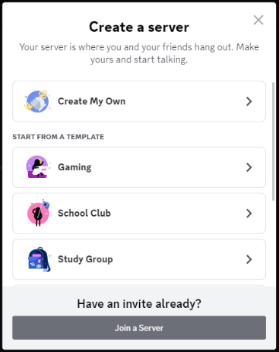
- When this icon is clicked, a menu will pop up with the option to create a server. This menu offers a blank server option for those who like to create servers from the beginning, but it also offers templates for those who would like to have a template to base their server off of. This tutorial on how to set up a server will begin from the basic blank template.

- When you select “Create My Own”, Discord will prompt you to “Tell us more about your server”, giving you the option to select either “For me and my friends” or “For a club or community”. Choose the option that best applies to your server, or select “Skip this question” at the bottom.
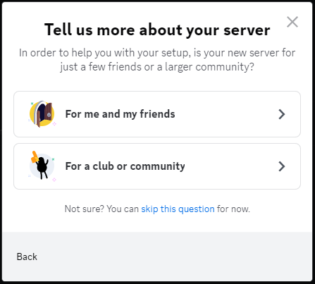

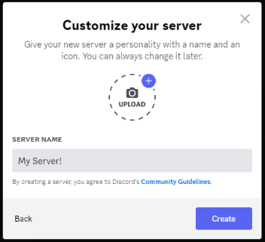
- After selecting an option from the previous screen, you will now be able to customize your server. During this step, you will name your server and also have the option to select an image that will show up in the left most pane to represent your server. Both of these can be changed later if desired. After customizing, select “Create”.

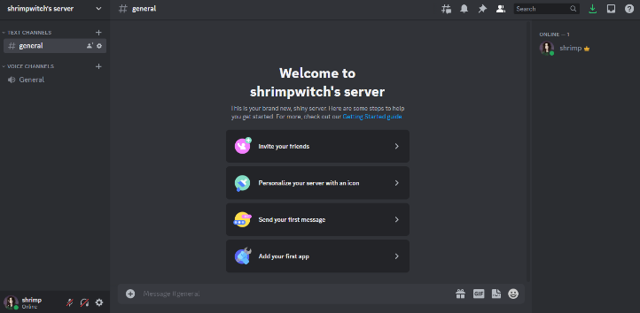
- Your server has been created! At this point, Discord will show you the main page of your new server, with a few quick links that you can click on to jump start the next steps to setting up your server, such as inviting friends or sending a message.

What are Channels?
When a server has been created, the host or administrator can organize this server by adding channels. Channels allow a moderator to create different sections in which members can discuss different topics. These channels show up in the pane to the right of the servers a user is a part of, and fall under the title of the server. In each server, when a user has clicked on it, they will see the name of the server at the top of the pane, and all the channels underneath it. Channels can be open to everyone, or they can be made private so that only certain users or users in specific roles can view and/or speak in those channels.
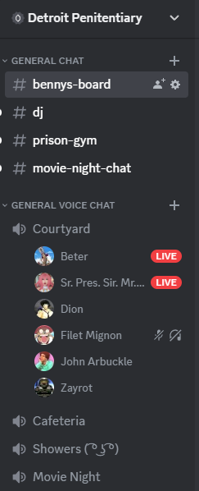
Title of server

Channels

There are two types of channels: Text Channels and Voice Channels.

Text Channels
These channels are spaces in which users talk exclusively using text, including images and emojis. As mentioned above, different channels can be created for different topics to create a sense of organization. These can be identified as having hashtags (also known as pound signs) next to the name of the channel.

Voice Channels
These channels are spaces where users can join to chat via voice and/or video. These channels can be identified by the sound icon to the left of the channel title. Users who wish to join a voice channel do not need to dial or ring in- you just click on the voice channel and you will automatically join through voice. All members of the server can see if you are participating in a voice channel, and can join as they would like. In these channels, you can opt to turn on your video, or you also have the option to share your screen.

How to Set Up a Channel
Discord users can create up to 500 channels per server, including both voice and text channels. Setting up these channels is incredibly simple but helps with keeping servers organized and letting users chat easier.
- After clicking your server, in the pane to the right of the server list where you can see the title of your server, you will see a down facing arrow next to the title of your server. Click on this to access the drop-down menu.

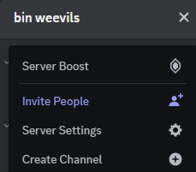
- In the drop down menu, select “Create Channel”

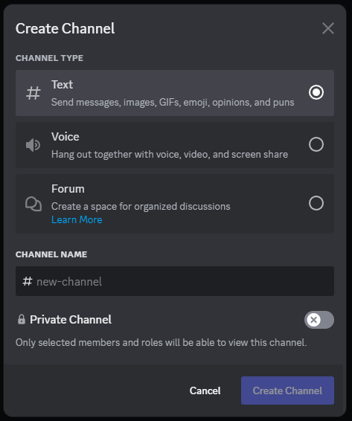
- After selecting “Create Channel”, a box will pop up where you can select the channel type you prefer, and name the channel. Once you make your selection and name the channel, you can choose whether you would like it to be public or private. Once you have finished, select “Create Channel”.

Adding Members
The most important part of a server is the people in it- so once your server is created, it’s time to add people to it! As mentioned above, after your server is created there will be a quick link to add members to your server. However, as messages are sent in the server, these links will disappear, and you will no longer have access to them. This section will cover how to add members when there is no quick link.

- In the server of your choice, select the down facing arrow next to the title of the server to access the drop-down menu.

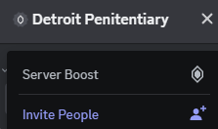
- Clicking this will make the server information drop-down menu appear. The second option, highlighted in blue with a human bust and plus icon, is “Invite People”. Select this option.

- After selecting this option, a box will pop up with suggested friends that Discord recommends you add to the server. Alternatively, at the bottom is a server invite link that can be sent through parties outside of Discord such as text or email. To send this link to a person, select the “Copy” button and paste it into a text field in the messaging app of your choice.
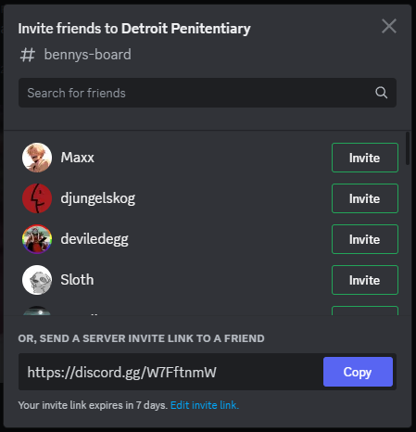

- The link you send will expire in seven days. When the link is sent, it will appear to the person it is sent to exactly as it appears in the invitation box that appears on Discord. The person being invited will have seven days to click on the link. When they click on it, they will automatically join the landing page in your server and be able to access the channels in the server. Be sure to greet them when they arrive!


Giving Roles to Members
One unique feature Discord offers is the ability to create “roles” in servers. Roles provide administrators the ability to limit or provide permissions to users in the server. This could include limiting or providing permissions including but not limited to muting users, locking channels, inviting members, and more. This ability can be abused, so it is important to only grant these permissions to members you trust.
- To access the ability to create roles, click the drop down arrow next to the title of your server.

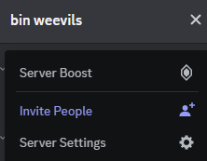
- Select “Server Settings” from the drop down menu.

- The server settings will automatically open to “Server Overview”. In the left column, select “Roles”.
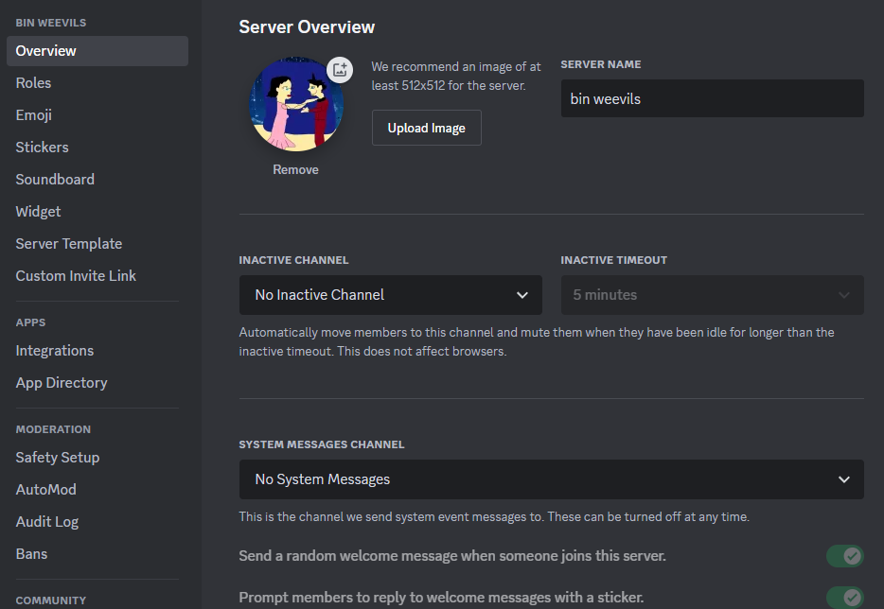
- Upon opening the “roles” pages, you will be prompted to create a new role. Select “Create Role”
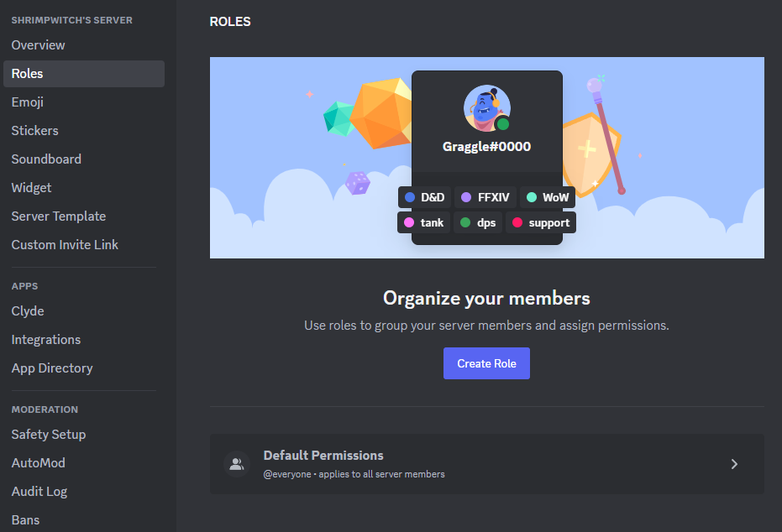
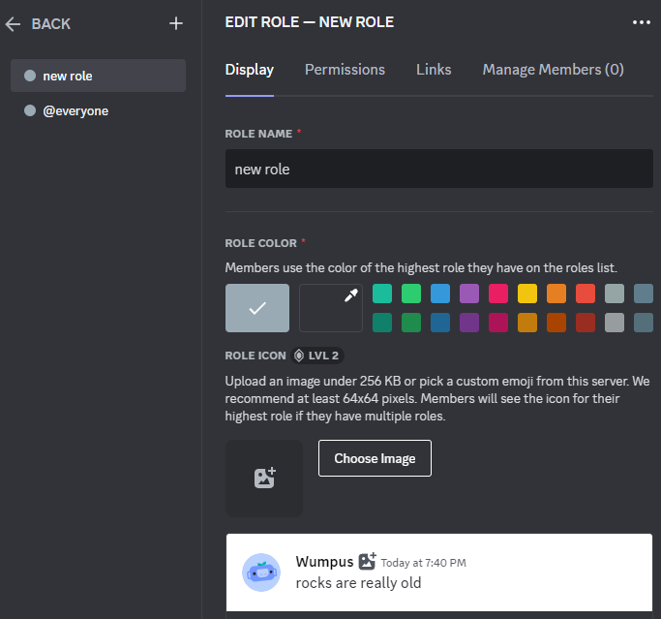
- Once on this screen, you can now change the name of your role. This will indicate which role is which. You can also change the color of the role, as well as select an image as an icon to represent the role. Now, click on “Permissions” in the top bar.
- In this category, you can choose the permissions that this role will have access to. There are over 40 permissions that you can grant to any one role. If you are seeking a specific permission, you can type it in to the “Search Permissions” search bar. When you have found a permission you wish to grant, select the while circle with an X in the center next to the permission, and it will change to a circle with a check mark to indicate it has been selected. Now click “Links” in the top row.
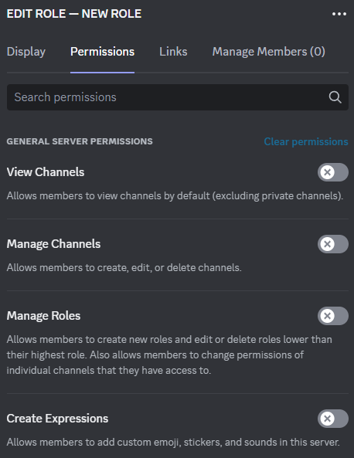
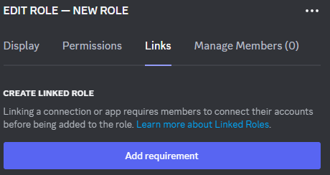
- Under “Links”, you can require that a member be connected to an app or another connection before being able to access their role. Now click “Manage Members”.

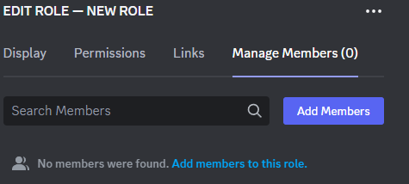
- In “Manage Members” you can look at all the members that a certain role has been applied to, and edit as needed. You can also add members by selecting “Add Members” on the right, and search friends to add them.

- As you enter information, an action bar will pop up at the bottom of the page.
When you have finished adding information and completed your role, click “Save Changes” in the action bar. This will save your role and allow you to apply it to members manually from now on.

Chatting via text
Within text channels, users have the ability to communicate via text. This method is straight forward, as at the bottom of a text channel is a space wherein users can type their message, and press “Enter” to send. There are a few things that Discord offers for those utilizing text channels, such as uploading files, sending emojis, and more.

Uploading Files
Through Discord, you can upload and send files such as JPG., PDF., PNG., and more through the text channels in a server.
- To send an file such as an image or a PDF, users can click the plus sign within the circle icon to the far left of the message box.

- Clicking this will open a menu with the following options: “Upload a File”, “Create Thread”, and “Use Apps”. To send a file, select “Upload a File”.
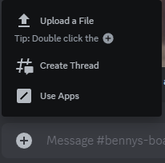
3. Selecting “Upload a File” will open the local files on your desktop, and you will be able to select the file you would like to upload. When you have selected the file you would like to send, it will appear in the text box of your message. If you would like to send an accompanying message, you can type it into the box. Once done, or if you decide not to type a message, simply press “Enter” and your message will be sent.
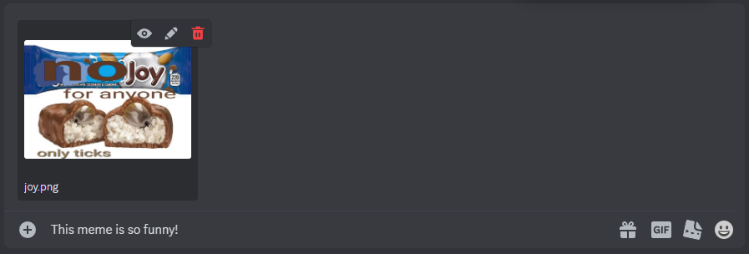

Sending GIFs
Discord has a wealth of in-app GIFs that are accessible by any Discord user.
- To search for GIFs, click on the rectangle icon with the word “GIF” to the right of the text box.
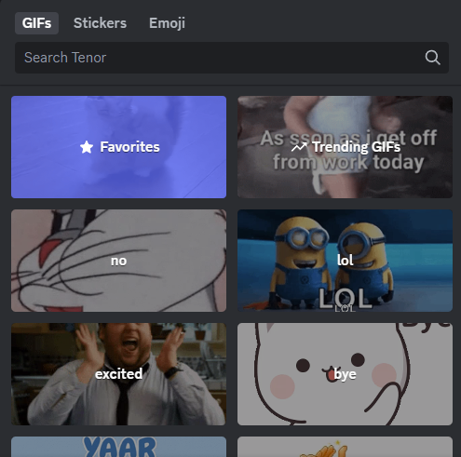
- Clicking this will open a box featuring popular GIF searches, GIF categories, and a text box that will allow you to search for a GIF of your choosing. To search for a GIF, type what you are searching for in the search bar at the top of the box.

- When you find the GIF of your choosing, select it to automatically send it to the chat that is currently open.
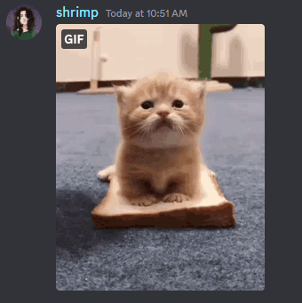
Sending Stickers
As with GIFs, Discord has a collection of stickers that users can select from to send in text channels. The process for sending these is about the same as sending GIFs.
- To search for GIFs, click on the icon with a smiley face to the right of the text box.

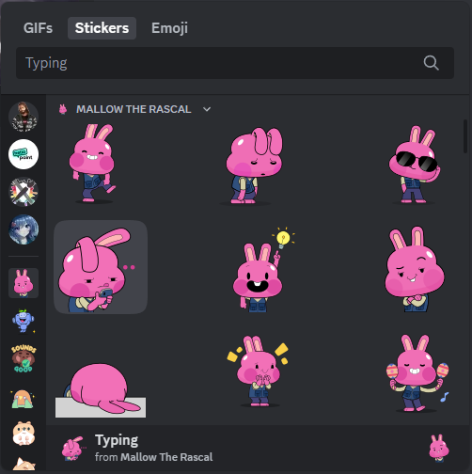
- Clicking this will open a box featuring popular sticker searches, categories, and a text box that will allow you to search for a sticker of your choosing. To search for a sticker, type what you are searching for in the search bar at the top of the box.
- Like with GIFs, as soon as you click on a sticker, it will automatically send to the currently open chat.
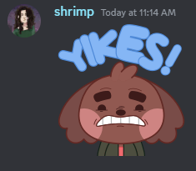

Sending Emojis
Discord contains the basic emojis that most platforms have, but also gives server admins the ability to create server specific emojis that can be used only in the server they were created for, by members of the server.
- To send an emoji, click on the smiling face icon to the far right of the text box, past the other icons.

- Clicking on this face will pull up a box similar to the ones for GIFs and stickers. Here, you can select an emoji or search for one.
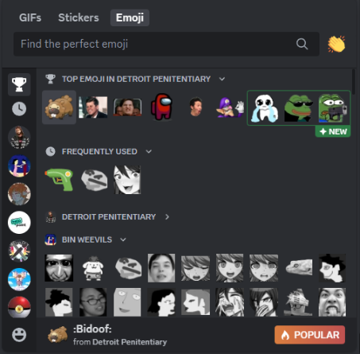

- Unlike when selecting a GIF or sticker, the emoji will not send directly to the chat, but rather become text in the text box. This text is a command to make the emoji appear, and it will do so once the message is sent. Below is an example of an emoji before being sent, and after being sent.
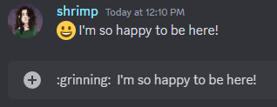

Bold, Italics, and More
In Discord, you can bold, italicize, underline, strikethrough, and bold italicize text. However, unlike doing so in a Word document or email, you cannot simply highlight the text and click a button to do this.
- To italicize: Wrap a phrase with a pair of single asterisks or single underscores.
- Example: *I am so happy to be here!* or _I am so happy to be here!_
- To bold: Wrap a phrase with a pair of double asterisks.
- Example: **I am so happy to be here!**
- To bold italicize: Wrap a phrase with a pair of triple asterisks.
- Example: ***I am so happy to be here!***
- To underline: Wrap a phrase with a pair of double underscores.
- Example: __I am so happy to be here!__
- To bold underline: Wrap a phrase with first a pair of double underscores, then double asterisks, then vice versa at the end.
- Example: __**I am so happy to be here!**__
- To strikethrough: Wrap a phrase with a pair of double tilde.
- Example: ~~I am so happy to be here!~~

Chatting via Voice
Joining a video chat in Discord is as simple as clicking a channel to join it- literally!
- To join a channel, navigate to the left most pane of a server where the list of channels is.
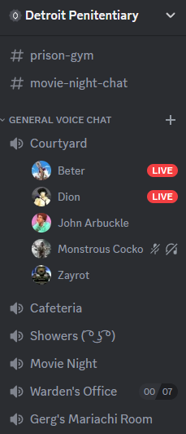
Here, you can just click any of the names of the voice chats to automatically join.

Streaming and Screen Sharing
Once in a voice channel, you can share your screen to the other users in the channel. Whether it’s a game you’re currently playing, a presentation to your workplace, or just showing pictures from your recent vacation, you can stream your screen to your channel.
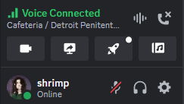
- Once you have joined a voice channel, navigate to the bottom of the left most panel in the server. Here, you will click on the icon of a monitor with an arrow that says “Share Your Screen”.

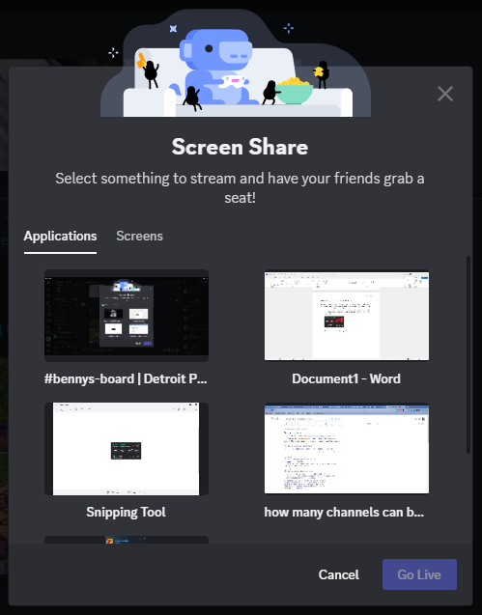
- Clicking on this will lead you to a pop-up box titled “Share Screen” that will contain all of the current applications you have up. You can select one of these tabs to choose which one you would like to stream, or you can select “Screens” to choose one of the monitors on your computer instead.

- After selecting the screen of your choice, a box will pop up to review what you have chosen to stream, and give you the option to change the frame rate of your video. It also gives you the option to get the Discord upgrade “Nitro” to increate the resolution. Once your have selected your preferred streaming options, click “Go Live”.
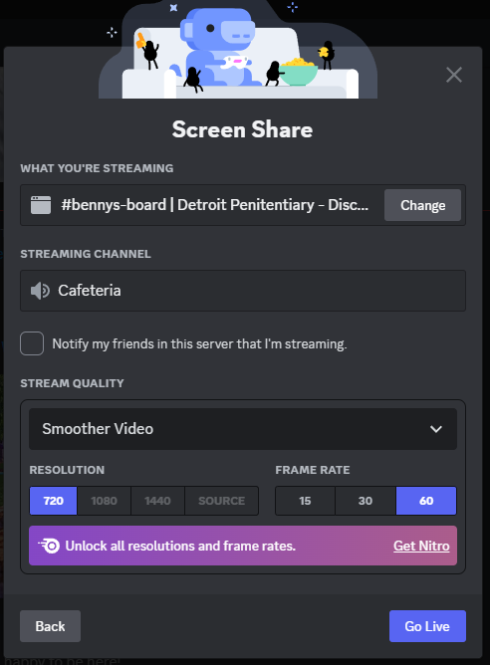
- Your screen is now being streamed! To end your stream, simply navigate to the pop-up window of your live stream, and select “End Stream”

Discord Support
For further information about how to navigate Discord, there is a Beginner’s Guide to Discord available on Discord’s web page. This can be accessed directly from the link below:
https://support.discord.com/hc/en-us/articles/360045138571-Beginner-s-Guide-to-Discord

For further help with navigating Discord from Discord Staff, you can visit Discord’s Help Center. This site contains beginner’s tips, announcements, and more. You can access the Help Center from the link below.
https://support.discord.com/hc/en-us

Discord also offers a page containing all the most frequently asked questions about their platform, and in-depth answers on how to navigate their application:
https://support.discord.com/hc/en-us/categories/115000168371

Credits
A huge thank you to Discord and its staff, developers, and creators for making a unique platform that works amazingly for so many audiences. This platform has been revolutionary in so many communities and provided so many extraordinary communication opportunities for friends, businesses, and families.
Discord: https://discord.com/
Download Discord: https://discord.com/download
Discord Help Center: https://support.discord.com/hc/en-us

